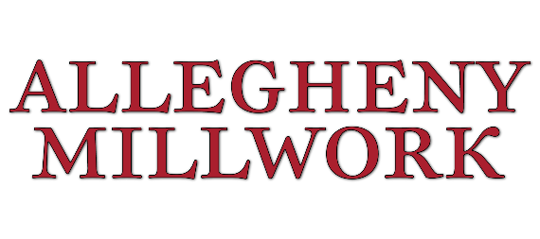

PRE-TASK PLAN

Project |  |  |  |  |  |  | Crew Size
General Contractor
Superintendent
Location of Task
Task to be Accomplished
Start Date |  | Start Time |  |  | End Date |  |  | End Time

Please Consider the Work to be Performed and Check “Yes” or “No” (Attach Additional Information as Needed):

1 | Does every crew member know how to use assigned tools & equipment? | ☐Yes ☐No | 10 | Are there occupied spaces adjacent or below? | ☐Yes ☐No
2 | Does this work require special training? | ☐Yes ☐No | 11 | Have shop drawings, contract drawings & as builts been reviewed? | ☐Yes ☐No
3 | Do you need additional or special personnel to complete this task? | ☐Yes ☐No | 12 | Will there be discharge of fluids? | ☐Yes ☐No
4 | Do you need additional or special materials and tools to do the job? | ☐Yes ☐No | 13 | Do other subcontractors need to be involved? | ☐Yes ☐No
5 | Do you need to review an SDS to proceed with this work? | ☐Yes ☐No | 14 | Does this task require any special permits/procedures? | ☐Yes ☐No
6 | Is there adequate lighting and access? | ☐Yes ☐No | 15 | Are employees assigned a “buddy”? | ☐Yes ☐No
7 | Will weather conditions affect the safety or quality of this work? | ☐Yes ☐No | 16 | Crew knows locations of fire extinguisher, eye wash and phones? | ☐Yes ☐No
8 | Does this task require shutdown of systems or equipment? | ☐Yes ☐No | 17 | Does work involve awkward positions, heavy or repetitive lifting? | ☐Yes ☐No
9 | Is there any potential to impact existing Owner or Construction activity? | ☐Yes ☐No | 18 | Other: | ☐Yes ☐No

Check if Any of the Following Apply (Attach Additional Information as Needed):

☐Public Interface ☐Confined Space ☐Electrical Hazards ☐Critical Lift Plan
☐Traffic Control ☐Chemical Exposure ☐Lock-Out/Tag-Out ☐SDS/HazCom
☐Barricades/Signs ☐Ventilation ☐Open Flame Welding ☐Fall Protection PPE
☐Respirator PPE ☐Hand/Arm PPE ☐Hearing PPE ☐Full Body PPE
☐Eye/Face PPE
☐Other: ______________________ ☐Other: ____________________

Coordination Effort With Other Trades:

☐ | Mechanical |  | ☐ | Structural
☐ | Electrical |  | ☐ | Other
☐ | Plumbing |  | ☐ | Other
☐ | Work Conditions
☐ | Equipment Required

Task |  | How Do I Reduce the Potential for Injury?
1 |  | Hazard
 |  | Control Measure
2 |  | Hazard
 |  | Control Measure
3 |  | Hazard
 |  | Control Measure
4 |  | Hazard
 |  | Control Measure

Task |  | How Do I Reduce the Potential for Injury?
5 |  | Hazard
 |  | Control Measure
6 |  | Hazard
 |  | Control Measure
7 |  | Hazard
 |  | Control Measure
8 |  | Hazard
 |  | Control Measure
9 |  | Hazard
 |  | Control Measure
10 |  | Hazard
 |  | Control Measure
11 |  | Hazard
 |  | Control Measure
12 |  | Hazard
 |  | Control Measure

The following should be used to assist in eliminating or reducing hazards:

Task | LEAST Effective | Moderate | MOST Effective
Elevated Work | Ladder & Permit | Scaffolding | Mechanical Lift
Material Handling | Lifting Limits | Proper Lift Training | Use Equipment
Electrical | LIVE Work | Signs Identifying Hazard | Lock-Out/Tag-Out

Crew Member Name | Signature | Position

